CO3 AT 3
A JOSHITHA ITA1407 ETHICAL HACKING
192421291
Question 16
Analyze a network where ICMP echo requests are blocked. Determine another host discovery technique.
Command 1
nmap -PS 192.168.56.0/24
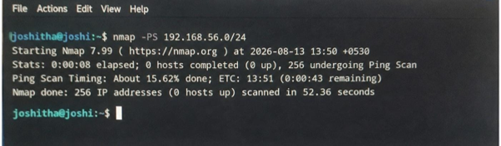
Performs TCP SYN host discovery to identify active hosts on the network without using ICMP ping requests.
Command 2
arp-scan --localnet
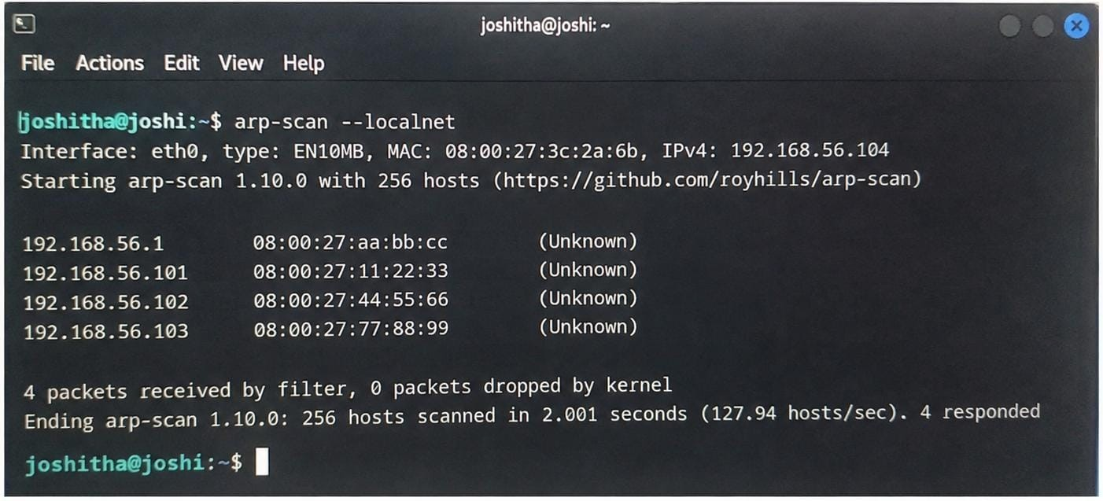
Scans the local network using ARP requests to discover active devices and their MAC addresses.

